Greece after the "No" vote
06 July 2015
- The Greek No vote means more uncertainty ahead regarding Greece, with significantly heightened risk of a Greek exit from the Euro.
- The threat of a flow on to other Eurozone countries is likely to keep markets on edge in the short term. However, contagion is likely to be limited as the rest of Europe is now in far stronger shape than was the case in the 2010-12 Eurozone crisis and defence.
- As a result we don’t see the Greek debacle derailing the European or global economic recoveries. So while the correction in shares looks like it might go further, the broad rising trend in markets is likely to continue.

Introduction
I am now getting very wary about going on holidays because invariably markets hit a rough patch whenever I do. That has certainly been the case over the past week with both a sharp pull back in Chinese shares and an intensification of uncertainty regarding Greece.
Two weeks ago it looked like Greece was heading for a deal with its creditors. Then at the last minute Greece’s Prime Minister, Alexis Tsipras, decided he didn’t like what was on offer from the Eurozone, the IMF and the ECB and called a referendum on it. This has seen Greece miss a June 30 €1.5bn payment to the IMF (which the IMF so far has called being in “arrears” albeit a declaration of “default” is likely by the end of July) and its banks shut with limits on ATM withdrawals (as Greeks have naturally been taking their money out for fear their deposits will be redenominated into a less valuable currency than the Euro) and on the verge of insolvency if something is not resolved soon.
The referendum has now been held and the No vote has won, with roughly a 60% of the vote. This note provides an update on what it means and the key things to focus on regarding Greece.

Implications of the No vote
The No vote means significantly increased uncertainty around Greece. At a high level it either means:
- Back to the negotiating table for a deal – this is not impossible, with worsening bank related chaos in Greece providing an incentive for Greece to reach some sort of agreement. So back to the negotiating table is likely to be the first (at least attempted) step. But it’s hard to see the creditors relenting easily particularly given the lack of trust they have of the current Greek Government and the desire to avoid a precedent by appearing too easy with Greece.
- Greece continuing to default with a €3.5bn payment to the ECB on July 20 but remaining in the Euro. Just because Greece defaults would not automatically mean that it will leave the Euro. Much would depend on how supportive the ECB will be of Greek banks. But in the absence of any prospect of a deal and growing bank insolvency risk this is likely to be cut off, particularly once Greece defaults on its July 20 payment to the ECB.
- Exit the Euro (Grexit) – in order to avoid even more aggressive austerity (as in the absence of support from the rest of Europe Greece will have to start slashing public spending as tax revenue is now plunging) and support its banks Greece will likely decide at some point that it needs to start printing its own money (which would probably have a value 50% below that of the Euro). Since it can’t do this in the Euro it would have to exit. This may take several months to unfold and it could be very disorderly and very bad for stability in Greece.
So the No vote means a worsening chaos for Greece and more Greek related uncertainty for global markets.

What really matters
The bottom line is that uncertainty around Greece is set to drag on for a while. But while the plight of Greece is terrible there are several reasons not to be too alarmed in terms of the global implications.
First, Greece is a very small economy that has been getting even smaller. It’s just 0.25% of global GDP, it takes just 0.5% of Eurozone countries’ exports and it’s a trivial market for Australian exports. So the direct impact on the Eurozone, the global economy and Australia is virtually non-existent. Rather the relevance comes via Greece’s membership of the Eurozone common currency and its potential to de-stabilise it. On this front the threat is substantially reduced from several years ago – see the next few points.
Second, the Greek crisis is now nearly six years old and private exposure to Greek public debt is now very low at just €50bn, with 80% of Greek public debt held by the IMF, the rest of the Eurozone and the ECB. Similarly the exposure of the global banking system to Greece is now low having fallen from $US300bn in 2008 to $US54bn last year. So the exposure and risks are well known with the result that a GFC/Lehman style shock – where global lending markets seize up as financial organisations worry about counterparty risk – is unlikely.
Third, other vulnerable Eurozone countries – namely Portugal, Ireland, Spain and Italy – are all now in much better shape than was the case when Greece triggered the Eurozone sovereign debt crisis over the 2010-12 period:
- Budget deficits have fallen substantially in Portugal, Ireland, Spain and Italy, with average public debt to GDP levels starting to trend down.
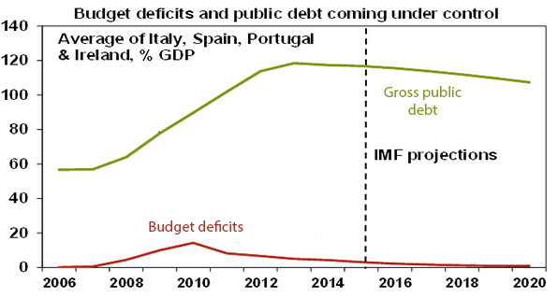
Source: IMF, AMP Capital

- Portugal and Ireland have now successfully come off bailout support programs and are financing their budget deficits in bond markets.
- Portugal, Ireland and Spain have moved from current account deficits averaging around 8% of GDP in 2008 to current account surpluses which means their economies are no longer dependent on external financing.
- All these countries have made significant progress in terms of economic reform (and political reform in Italy’s case – note Berlusconi’s absence!) and are seeing much improved growth indicators. Spain and Portugal have seen a sharp reduction in their unit labour costs relative to Germany and the Spanish and Irish economies are amongst the strongest growing economies in the Eurozone.
Fourth, defence mechanisms to support troubled Eurozone countries are now much stronger than was the case in 2010-12 and investors are aware of this. This includes: a strong bailout fund (the European Stability Mechanism or ESM); the provision of cheap ECB funding for banks via TLTRO (targeted long term refinancing operations); a banking union and recapitalised banks; the ECB’s quantitative easing program which entails €60bn/month in debt purchases; the ECB’s Outright Monetary Transactions program which can be used to buy individual country bonds which backs up ECB President Mario Draghi’s commitment to do “whatever it takes” to preserve the Euro; and the threat the ECB might use “new instruments” if needed. All this should help keep bond yields in peripheral countries from being pushed too far above levels in Germany.
Finally, the economic and financial chaos that Greece has descended into will likely turn voters off supporting anti-austerity parties promising easy salvation in other countries. Most relevant in this regard is left wing Podemos in Spain given that Spain has a general election due at year end. In fact, support for Podemos peaked late last year.
The last three points mean that there is a much reduced chance that a Greek default and eventual exit from the Euro will prompt investors to look for other countries that may do the same – and so cause an excessive blowout in their bond yields.
In fact it increasingly looks like Greece is “the odd man out” in Europe so to speak. It set the wheels in motion of the Eurozone sovereign debt crisis in 2009, it triggered each of the crises that unfolded in 2010, 2011 and 2012, it has not been able to sustainably tap back into international debt markets unlike Portugal and Ireland and despite Herculean efforts has not been able to come through a mix of austerity and reforms without major political ructions unlike several other Eurozone countries. As such, it should really be seen as a special case.
Consistent with this – along with the improvement seen in other peripheral countries and the strengthening of defence mechanisms against contagion – it is noteworthy that the latest Greek crisis has not triggered anything like the financial market ructions in other peripheral countries seen through 2010-12:
- Bond yields in peripheral countries are a faction of the Eurozone crisis highs (as is their spread to German yields).

Ten year bond yields, now and then
Country | Current Level | Eurozone crisis high (low in Ger)
Spain | 2.20% | 7.51% (July 2012)
Italy | 2.24% | 7.20% (Nov 2011)
Portugal | 2.91% | 15.82% (Jan 2012)
Germany | 0.79% | 1.17% (July 2012)
Source: Bloomberg, AMP Capital

- The spread between Eurozone interbank lending rates and the expected ECB short term policy interest rate remains around normal levels, which is around one quarter that seen in July 2012 indicating that there is minimal stress in Eurozone short term money markets.
So while Greek related risk has further to play out and a Grexit would not set a good precedent as other countries could do the same (mind you I always thought they could if they really wanted to!), the probability of Greece causing a major crisis in Europe that threatens the global economy and financial markets appears to be low. As the Greece saga drags on investment markets will likely just get used to it as they have with the Ukraine conflict since early last year. If (or when) it does finally come down to a Grexit investors may just celebrate as the long running thorn in the side of the Eurozone is finally gone. So just bear that in mind next time you see the endless footage of understandably concerned Greeks lining up at their ATMs.

So what does this mean for investors?
First, Greece will likely cause more short term volatility in markets.
Second, investors should keep an eye out for the opportunities this throws up – notably in peripheral Eurozone country bonds and Eurozone shares, which on our analysis remain cheap.
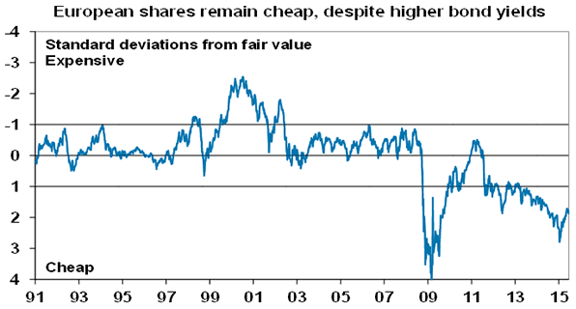
Source: Bloomberg, AMP Capital
Finally, while global and Australian shares have been undergoing a correction, partly due to Greece, the Greek drama is unlikely to derail their broad rising trend.

About the Author
Dr. Shane Oliver, Head of Investment Strategy and Economics and Chief Economist at AMP Capital is responsible for AMP Capital's diversified investment funds. He also provides economic forecasts and analysis of key variables and issues affecting, or likely to affect, all asset markets.

